**EXP:- LAMP USING SWITCH**

**Circuit diagram: -**

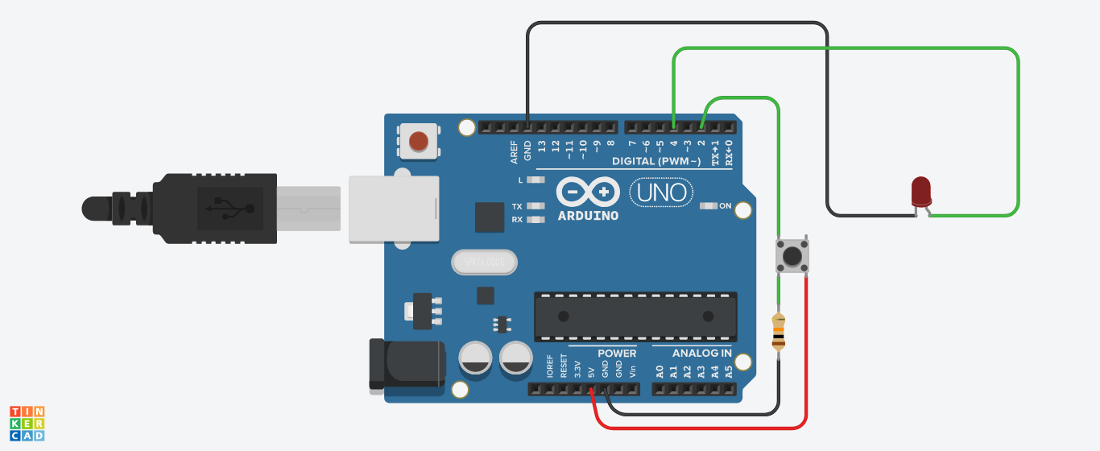

**Concept Used : -** A circuit is made in which 2 digital pins are used where a pin (lets say 4) is connected to a LED which is further connected to ground. Now another pin (lets say 2) is connected to switch. One end of the switch is connected to 5V supply and intersection of pin 2 and switch is connected to resistor which is connected to ground from another end. Value of resistance is very high. The resistors are used to resist the flow of current. Coding is done in such a way that when switch is pressed led turns on and again when switch is pressed led turns off.

**Learning and Observations : -**

• Making circuits using Arduino.

• Connecting LED and switch with arduino.

• Ground has least resistance.

• Working of Arduino UNO.

• Coding to be done on Arduino.exe for stimulation of the experiment.

**Precautions :–**

1. The circuit made can be wrong.

2. Any Element used may be defective.

3. The coding done can be incorrect due to which stimulation can be failed.

4. Port Selection for Arduino can be incorrect due to which it won’t upload on

Arduino Board and resulting in failure of experiment.

**Learning Outcomes: –**

1. Setting up circuit on a Arduino.

2. Connecting switch, LED and Arduino.

3. Using switch and LED.

4. Working and coding of Arduino.

**Result: –**

Working of led and switch verified after uploading the program. Lamp is ready to

glow.